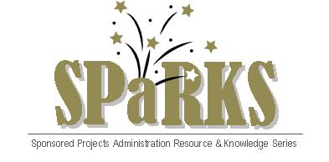

Module 8: Award Management (Part II)

July 20, 2011
Instructor: | Phone: | E-Mail:
Terri Vallery  Jaswinder (Cookie) Kaur  Greg Robinson | 882-1186  882-2228  823-5348 | terri.vallery@ucf.edu  jaswinder.kaur@ucf.edu  gregory.robinson@ucf.edu

Module Description
Overview of the Award Management process (Part II).

Module Overview
This is the second of a two-part module that covers the award management process. The purpose of this module is to introduce the SPaRKS participants to the purchasing and procurement process, invoicing and cash management, and the rules and regulations pertaining to effort reporting.

Module Objectives
- Participants will understand the anatomy of an account number.
- Participants will learn the cash management process.
- Participants will gain a better understanding of program income.
- Participants will understand invoicing terms and the invoicing process.
- Participants will learn about purchasing and procurement guidelines.
- Participants will gain a better understanding of the rules and regulations that govern effort reporting.

